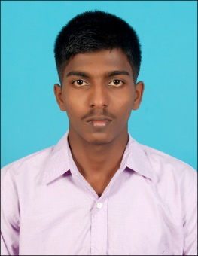**GOWTHAMAN V**

**+91 9363317466**

[**gowthamanvai@gmail.com**](mailto:hariharann.96@gmail.com),

49/17,4th cross,Bommanahalli signal,

Archana Hotel Road,

Bangalore-68.

**CAREER OBJECTIVE**

To gain employment in an organization that assists me in achieving high career growth through continuous learning and keeps myself dynamic and competitive.

**PROFILE SUMMARY**

* Ability to work both as a team leader and team player.
* An athirst competitor and quick learner.

**EDUCATIONAL QUALIFICATIONS**

|  |  |  |  |  |
| --- | --- | --- | --- | --- |
| **S.NO** | **COURSE** | **INSTITUTION** | **YEAR OF PASSING** | **SCORE** **OBTAINED** |
| **1** | B.E Electronics & Communication Engineering | Meenakshi  Sundararajan  Engineering  College | 2018 | 75.4% |
| **2** | HSC  XII | Government School | 2014 | 92.1% |
| **3** | SSLC  X | Government School | 2012 | 89% |

**AREAS OF INTEREST**

Kernel Development, RTOS, Device Drivers, Embedded Systems.

**INTERNSHIP TRAINING**

* Undergone Ten Months Internship Training at Innointel Global.

**PROJECTS UNDERTAKEN**

* Data gathering from website using Python-Scrapy Framework.
* Building Chat Bot using Telegram for Insurance Claiming Application.
* Named Entity Recognition Using IBM-Watson Knowledge Studio.

**TECHNICAL SKILL SET**

* Programming Language. : Python,C.
* Framework : Scrapy.
* Libraries : Standard Libraries, Numpy, MatplotLib etc.
* Operating System : UNIX/Linux.
* GitHub : [gowthamantechy.](https://github.com/gowthamantechy)

**PAPERS PRESENTED**

* Cryptography and Network Security.
* The ghost of universe: Nutrino particle.

**BIODATA**

Date of Birth : 10-06-1997

Gender : Male

Nationality : Indian

Father’s Name : VAIKUNDANATHAN A

Mother’s Name : THILAGAVATHI S

Marital Status : Single

Languages known : Tamil and English

Permanent Address : 7-87, Meladharmapuram, Eathamozhy, Kanyakumari-629501.

**DECLARATION**

I hereby declare that all the details furnished above are true to my knowledge.

**Place:** Bangalore

**Date: GOWTHAMAN V**